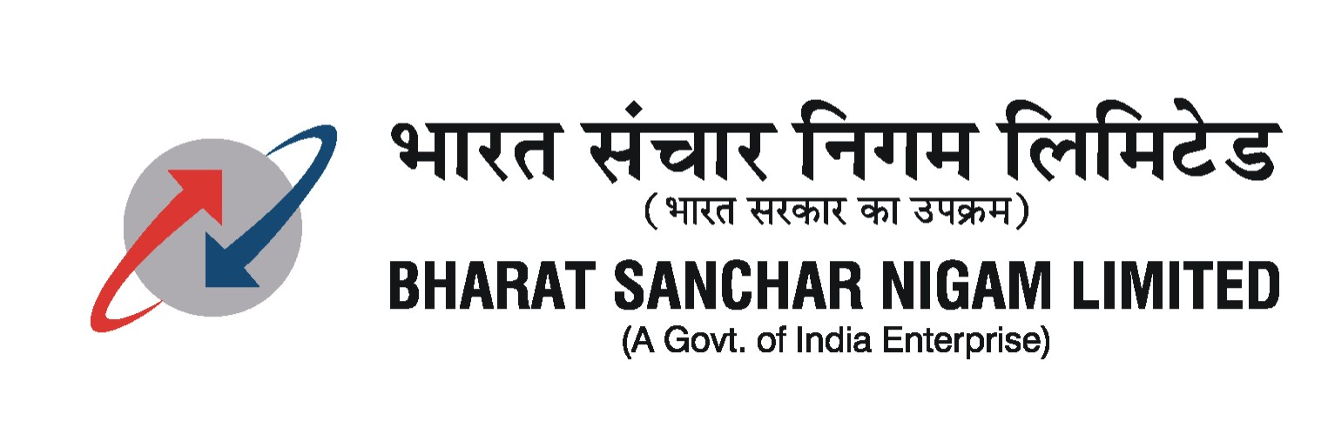
Broadband cell
BSNL Corporate Office, II Floor
Bharat Sanchar Bhavan, Janpath, N.Delhi-110 001
Ph. 011-23037155 Fax.011- 23734052

No:64-86/09-S & M –CFA dt 25-11-09

Sub: Minutes of the Franchisee Meeting for CFA Business held on 19/11/09 at Corporate Office

The formal meeting started with welcome by GM (NWP-BB) and introduction by individual participants. GM (NWP-BB) emphasized the need to put focus on Fixed Access products like sale of landlines, broadband, landline VAS and Broadband VAS services. He informed about the total revenue of BSNL and the major part that Fixed Access Business plays in the overall BSNL scheme of things. He also informed that last year, gross 20 lakh landlines and 15 lakhs Broadband connections were given by BSNL and if franchisees put efforts they can at least bring the same number of landline & broadband connections as achieved by BSNL from now onwards. Also, the fact that total sale of ITC cards is around Rs 300 Crores only, which has major scope for expansion. The commission structure was also told and confirmed. The discussion then took place on individual services.

- Landlines:

Representative from TN put up several points:

- Instrument sets and indicator numbers should be issued to franchisees in advance.
- If possible, DOTSOFT/TRICHUR (Billing) terminals be extended to them so that they can do their bookings themselves.
- Updated list of feasible areas should be given to the franchisees every month.
- Installation should be ensured at least within 48 hours, if the area is feasible, because the private telecom operators are providing the connection in 24 hours.

Representative from Kolkatta informed that booking of new landline connection and submission of form is very difficult. For 12 forms we have to go to entire Kolkatta. The staff is not behaving well. We are booking 200 to 250 connections per month but not getting any payment. He asked for 50% upfront payment on deposit of the forms. Representative from Orissa informed that CLIP handsets are distributed in an arbitrary manner and that the norms for replacement of handsets should be clear and transparent. They have suggested that if any customer wants clip phone on priority, the same can be given by charging Rs.100/- and the same may be reflected in the next bill, if possible. Representative from HP talked of each retailer being given a free incoming-only landline and the retailer will take ITC cards for making outgoing calls. There was lot of discussion on the commission being less and to make it attractive to the franchisees. Representatives of Haryana and Rajasthan have shown concern about service of telephone lines, as it takes 10-15 days for setting the phone in order.

GM (NWP-BB) agreed with the idea in principle:

  - That the circles will be written for accepting the application forms nearest to franchisee location by one nodal officer.
  - It will be examined if the commercial system terminal can be extended at the franchisee location.
  - Only those forms shall be accepted which are of technically feasible areas.
  - Circles will be asked to fix the landline connection targets in consultation with the franchisees and they have to be reasonable and realistic.
  - Commission structure to be examined by Corporate Office in consultation with Finance wing.

Suggestions:
Rs 500 be the basic commission. 100% upfront commission for the feasible area & if the connection gets disconnected within 6-months, 50% commission will be recovered. Commission to be paid in the form of ITC cards only.

- Broadband

Franchisees pointed out about the shortage of modems and requirement of Type II modems. Also they complained about the connections booked by them not getting installed in time. GM (NWP-BB) informed them about the broadband call centre no. 1504 and asked suggestions for reducing the repair time for broadband complaints. Representative from UP (W) asked for the work of installation and maintenance of broadband connections be handed over to franchisees on paid basis with SLA. The franchisees complained bitterly about the commission being insufficient. On the commission structure, following structure was suggested and the same may be decided after consultation with Finance Wing at Corporate Office:

Suggestion:

Commission to be paid upfront. One month rental to be paid as commission for upto Plan 500 and half-month rental for all plans higher than Plan500 subject to a minimum commission of Rs.500/-. The commission shall be recovered 100% if the broadband connection gets disconnected within 3 months. Commission may be paid in the form of ITC Cards only.

- ITC

GM(NWP-BB) pointed out that ITC cards can contribute to the tune of appx. Rs 1000 Cr to BSNL’s revenue, if popularized properly. He also said that sufficient marketing material would be made available to the franchisees for selling these cards and BSNL may work out schemes for the next 4-months. Franchisee representative from Rajasthan, Orissa and West Bengal complained about the minimum limit of purchase of ITC Cards as Rs One lakh is on the higher side and suggested to bring down to say Rs.25,000/-. Also, the fact that a large no. of ITC cards which are nearing expiry are lying with the circles which they issue to the franchisees. Hence, there is reluctance from the franchisee side to buy the cards from BSNL. Also, the franchisees pointed out that call rates are also to be looked into by BSNL to make these cards more attractive to customers in the face of universal availability of mobile prepaid cards. Finally, after a lot of discussions, following was suggested:

Suggestion:

The following suggestions are to be examined in consultation with Finance.

  - Corporate Office would write to circles not to issue such ITC cards to franchisees whose validity period is less than 6 months.
  - 20% of the total supplied cards, if expired, lying with the franchisees can be considered for replacement with fresh cards having validity remaining not less than 6 months.
  - Franchisees would inform about the details of ITC cards lying with them and if BSNL agree, a proposal for one-time amnesty may be given in the form of one-month’s validity for those existing expired cards.
  - Rounding-off of the amount of ITC cards in line with mobile prepaid cards as being considered for prepaid recharge vouchers may be considered.

- Landline VAS & Broadband VAS

GM (NWP-BB) made the mention of various value added services offered by BSNL on Broadband Network and on landline like, PRI, IN Services, ISDN service, etc. To which, most of the franchisees told that they are not aware of the PRI, IN services and even about the ISDN services. Also, ignorance is there about the broadband VAS services. GM(NWP-BB) told that to address the issue, a zone-wise training programme would be chalked out at Delhi wherein one day training for these services will be imparted to the franchisees. All the franchisees requested that the training be scheduled at Corporate Office between 15-31st December, 2009, the same was agreed to by GM (BB). For most of the VAS services, currently no commission structure is available and Corporate Office would examine the same in consultation with Finance Wing of Corporate Office.

- Other Issues

Franchisee representative from Punjab pointed out that bill collection and payment of landline bills through C-Top up can be allowed to them. It was agreed that the issue would be looked into.

Before the formal start to the meeting, GM (CSC) interacted with the franchisees. He informed that to improve the focus on CSCs, a separate cell has been created at Corporate Office. The following points emerged from the discussions:

- The staffs sitting at CSC counters do not respond well to the representatives of Franchisees visiting the CSC with the NTC applications or various other works. They consider them as outsiders and are found wanting in knowledge also.
- CSC staff should be made aware about the feasible areas list.
- Representative from J&K told that since prepaid mobile connections have been withdrawn from J&K state recently, there is a heavy rush for postpaid applications and CSC staff is not taking the applications from the franchisee’s representative. Also, the connections booked in CSC are given priority for activation.
- Representative from Orissa told that lot of hassles are faced while asking for replacement SIMs from CSC staff and that the procedure needs to be streamlined.

GM (CSC) informed that behavioral issues are being addressed and a pilot project has been started in Nagpur which will be evaluated in March, 2010. Stress is being given for placing staff in CSC who have right attitude. Training module is being prepared and also schemes are being thought for incentivising the CSC staff for motivation. Also, some process re-engineering is being indulged into so that proper ambience is created in CSCs.

Director (CFA), while inter-acting with the franchisees, stressed upon the following to be taken up by franchisees on priority basis:

- Centrex to Group Housing Societies.
- PRI
- Engagement of video conferencing equipment manufacturers and marketing of video conferencing on BSNL broadband. He also promised that a booklet containing description of services and tariffs will be prepared and the same will be distributed to all franchisees for ready reference.
- He asked GM (NWP-BB) to explore possibility of using ALTTC for training of franchisees.

The above minutes are issued with the approval of competent authority.

Sd/-
(Vishwa Mohan)
DGM(S&M)-CFA

Copy:
- CMD/Director(CFA) for kind information please
- All CGMs(Territorial Circles/Metro Districts) for inf. and n/a
- GM(NWP-BB)/GM(F)-CFA/GM(CSC) for kind information please
- All franchisee representatives present in the meeting

